Executive Summary
Write this piece last – it sums up the plan. Include an overview of the organization and the top-level Strategic Imperatives that are developed during your planning session:

Mission, Vision & Values

Identify the company’s Mission, Vision and Values here; each should be designed or reaffirmed during strategic planning.

- Mission – Describe what your organization does every day – what is its primary purpose – this should tell those who are unfamiliar with your organization what you do and the value you are trying to provide.

- Vision: Describe the ultimate future-state of your organization – if your Mission was fulfilled completely, what would the organization look like?

- Values: This is optional, but highly recommended. It tells your employees, clients and the world what the organization stands for and how it carries out business.

Capabilities Agenda
The Capabilities Agenda identifies existing and desired capabilities to retain existing clients by highlighting existing capabilities, as well as capturing new clients by acquiring and mastering new capabilities. Use the Capabilities Agenda framework in the Essential Strategy Toolkit.

SWOT Assessment & Mapping
SWOT assessments are used to determine an organization’s abilities and obstacles for achieving its Capabilities Agenda – SWOT Mapping identifies priorities to support Mission, Growth & Survival. Use the SWOT Matrix and SWOT Heat Map frameworks in the Essential Strategy Toolkit.

Mission Critical Objectives
Based on the SWOT Mapping exercise, identify critical priorities across its Mission, Growth and Survival perspectives developed during the strategic planning workshop.

Strategy Execution, Monitoring & Adjustment
Discuss how the Strategic Plan connects to the Operational / Business Plan, and the organization’s process for monitoring, adjustment and reporting.

List of Appendices

- Essential Strategy Foundation
- Capabilities Agenda
- SWOT Matrix
- SWOT Heat Map
- Tactical Goals Matrix

Appendix A Essential Strategy Foundation

COMPANY’s approach to strategic planning is based on Essential Strategy, a balanced approach to Mission, Growth and Survival using a Mission Critical focus.

Mission ensures that resources are expended, and strategic initiatives are focused on furthering the organization’s Mission, creating an internal attribute of intention and purposefulness.

Growth identifies a clear need for the organization to be in a continual growth mode, realizing that true growth is only that activity that exceeds replenishment efforts. By combining internally efficient operations with an active and intentional survey and pursuit of external opportunities, we create agility.

Survival ensures that appropriate attention is given to organizational continuity efforts, including succession planning and critical systems protection, to both enhance infrastructure for growth and competitiveness as well as addressing operational and strategic resiliency.

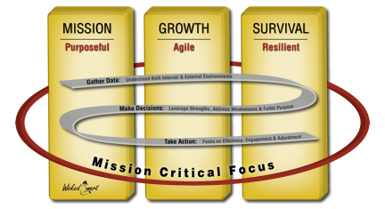
Finally, a Mission Critical focus allows the organization to appropriately prioritize activities in all spectrums by allocating and directing available resource in areas that will make the most impact, providing clarity of purpose and reducing low value efforts.

Across these pillars, a solid business practice of Learn, Decide, Act drives an iterative internal process. Learn requires the gathering of business intelligence both internal and external to the organization to serve as the foundation for making critical Decisions about strategy and operations. The Act element highlights the need to incorporate tactical execution into the plan, including realistic goals, measureable targets and a process for monitoring and reporting to allow for course adjustment as necessary.

