The ANC Board Chair/President Forum™

  - A Small-Group Forum
  - for

  - ANC Board Chairs & Presidents

  - Exchanging Ideas and Experiences to Support Personal and Organizational Leadership Excellence

Why Join the ANC Board Chair/President Forum?
The Benefits
- Small Group Size (8-10)
- Non-competitive Members
- Confidential Environment
- Expert Management Facilitators
- Dynamic Guest Speakers
- One-on-One Touch-Base Calls (quarterly)
The Investment
- Meets twice per year for 1.5 days per meeting

- Annual Dues $4,750
There is tremendous value to be gained in learning from others.
Joining the ANC Board Chair/President Forum provides an opportunity to explore critical leadership issues and to develop and share ideas, solutions and experiences in a trusting and confidential setting. Forum members find the opportunity to confidentially exchange ideas, discover creative solutions, avoid missteps and gain insight into coping with the challenges they encounter invaluable. Past and current members of our forums have found their time, investment and participation highly beneficial.
Forum membership excludes direct competitors while building a diverse group to support an ongoing engaging and productive dialogue. Bi-annual Forum Meetings are planned at destination locations to allow focus and full engagement of the group, and create an environment for peer mentorship, camaraderie and learning.
Forum Facilitators
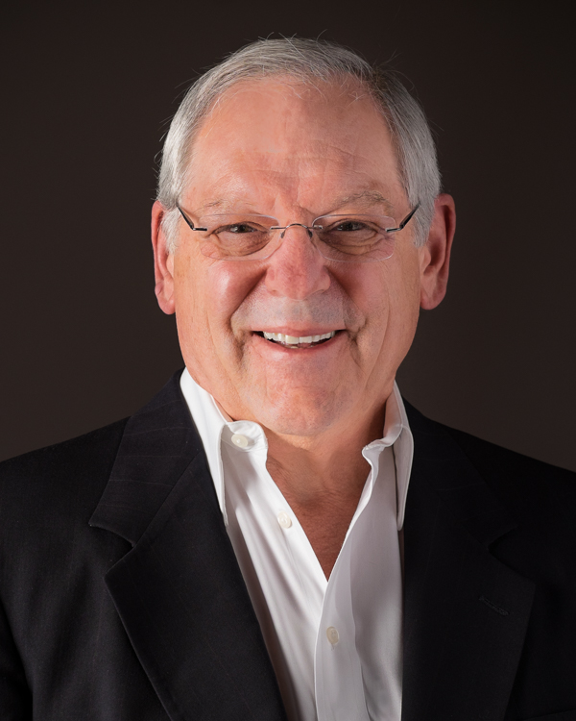 | Harvey A. Meier, PhD, CMC® is a certified management consultant (CMC®) and executive director of the Institute for ANC Director Education®. For over 46 years he has served as a strategic business and confidential advisor to boards, CEOs, and owners of privately held for-profit and non-profit corporations and organizations. His clientele represent a wide range of industries including Alaska Native Corporations and Tribes. Clients retain him for guidance on board governance best practices, strengthening the partnership and working relationship between the board and CEO, and between the tribal council and tribal administrator. He is publisher and co-author of the ANC Director Guidebook Series (Board Governance Best Practices, Robert’s Rules of Order Made Easy, and Monitoring Financial Performance). For over 25 years he has served as founder and chair of the CEO Focus Group in the Lower 48, a forum for CEOs of shareholder owned companies focused on sharing ideas, solutions, and experiences in a confidential and trusting setting similar to the ANC Board Chair /President Forum. Specific information about Harvey can be found at www.ancdirectoreducation.com.

Erin Sedor is an emerging thought-leader in the area of strategy, risk and resilience, possessing more than 26 years-experience as a risk professional, c-suite officer, board chair and now executive consultant. Erin has a particular talent for identifying hidden risks and missed opportunities that hinder growth, helping her clients fine-tune performance without unnecessary complexity or reinvention. Her experience in with building hybrid programs led her to develop Essential Strategy - a balanced approach to Strategy, Risk & Resiliency that fits companies of all sizes, sectors and complexity. Her diverse experience, ability to bridge cultural communication gaps and passion for furthering leadership excellence in the Board and C-Suite is what brought her to the ANC Board Chair/President Forum. Erin holds an MBA in Operational Risk, BA Degrees in both Finance & Organizational Management, a Professional Certification in Legal Studies, and she is an IADE and RIMS Fellow instructor. Learn more about Erin at www.BlackFoxStrategy.com.

